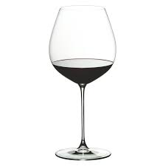
The Wine Cellar

Contact: 610-730-3275
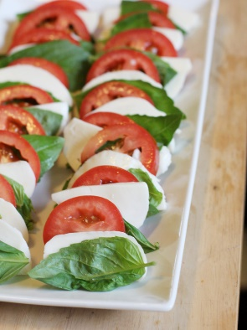
Address: 459 Main St, Bethlehem, Pa 18018
Holiday Specials:
- 10% off all cases of wine
- Bottle night- 50% off from our list of choices
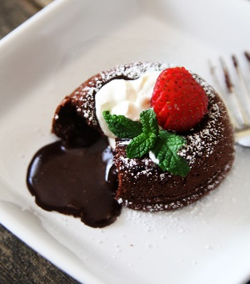
Wine of the month! (Wine Spectator Top 100)
- Pinot Noir
Happy Hour 7 days a week
3-6pm (half priced drinks)
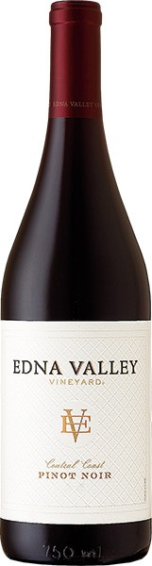
Tasty Tuesday- Purchase 3 wines & receive a complimentary appetizer
Wednesday- Ladies Night with discounted drinks
Thursday- Date night $5.00 select wines
Friday- 20% off Wine Flights 3 wine pours at a time

